**DAILY ONLINE ACTIVITIES SUMMARY**

|  |  |  |  |  |  |  |  |  |  |
| --- | --- | --- | --- | --- | --- | --- | --- | --- | --- |
| **Date:** | **26/06/2020** | | | | | **Name:** | | **NAIPUNYA VINOD NAIK** | |
| **Sem & Sec** | **IV SEM & A SECTION** | | | | | **USN:** | | **4AL18CS050** | |
| **Online Test Summary** | | | | | | | | | |
| **Subject** | | **NO INTERNALS CONDUCTED** | | | | | | | |
| **Max. Marks** | | **N/A** | | **Score** | | | | **N/A** | |
| **Certification Course Summary** | | | | | | | | | |
| **Course** | **1)** **PRACTICAL MONGODB: FOR ABSOLUTE BEGINNERS**  **2) LEARN PHP- FOR BEGINNERS**  **3) WEBINAR ON CYBER SECURITY AND APPLICATIONS** | | | | | | | | |
| **Certificate Provider** | | | **1)UDEMY**  **2)UDEMY**  **3)AIET** | | | | **Duration** | | **1)1.5 HRS**  **2)2 HRS**  **3)2 HRS** |
| **Coding Challenges** | | | | | | | | | |
| **Problem Statement: 1)**[Given start and end of a range, write a Python program to print all negative numbers in given range.](https://github.com/orgs/alvas-education-foundation/teams/2nd-year/discussions/137) | | | | | | | | | |
| **Status:- EXECUTED** | | | | | | | | | |
| **Uploaded the report in Github** | | | | | **YES** | | | | |
| **If yes Repository name** | | | | | <https://github.com/naipunya-naik/lockdown-coding/blob/master/PYTHON%20CODING/negative%20number%20range_26-06-2020.py> | | | | |
| **Uploaded the report in slack** | | | | | **YES** | | | | |

Online Test Details: (Attach the snapshot and briefly write the report for the same).

NO INTERNALS CONDUCTED TODAY

Certification Course Details: (Attach the snapshot and briefly write the report for the same).

CERTIFICATION COURSE NAME:- PRACTICAL MONGODB: FOR ABSOLUTE BEGINNERS

TODAY I COMPLETED THE COURSE OF MONGODB,I LEARNT A LOT ABOUT MONGODB AND ITS WEB APPLICATIONS.



2) CERTIFICATION COURSE NAME :- LEARN PHP- FOR BEGINNERS

TODAY I COMPLETED THE COURSE OF PHP,I LEARNT A LOT ABOUT USE OF PHP AND ITS APPLICATION OF WEBSITE DEVELOPMENT.



3) WEBINAR ON CYBER SECURITY AND APPLICATIONS

* CONDUCTED BY:- DR MANJUNATH KOTARI, HOD CSE,AIET
* DURATION:- 2 HRS
* FROM 9.00 AM TO 11.00 AM
* WEBINAR COMPRISED OF TWO QUIZZES ,QUIZ 1 & QUIZ 2
* QUIZ 1 COMPRISED OF 9 QUESTIONS
* EACH QUESTION CARRIED 1 MARK
* QUIZ 2 COMPRISED OF 8 QUESTIONS
* EACH QUESTION CARRIED 1 MARK.

SCREENSHOTS OF WEBINAR

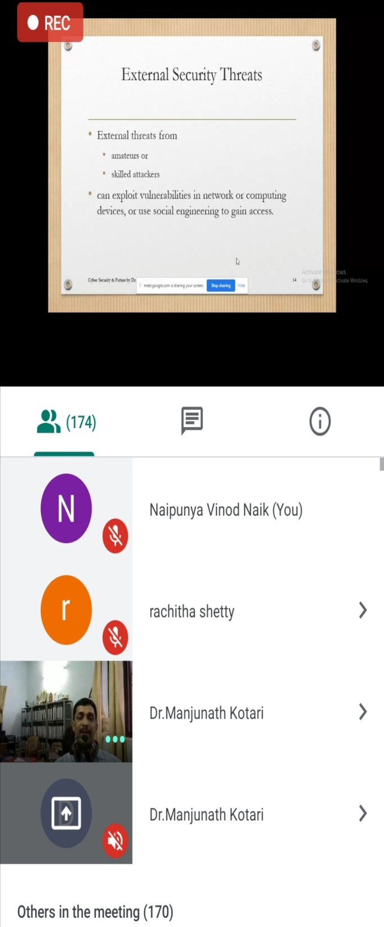 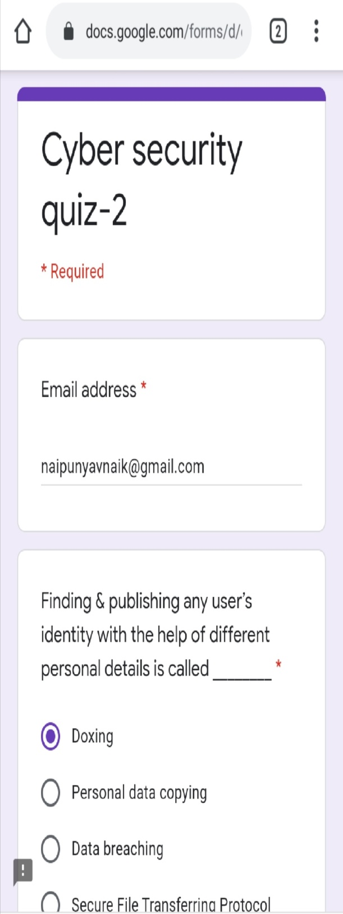

Coding Challenges Details: (Attach the snapshot and briefly write the report for the same).

PROBLEM STATEMENT :-[Given start and end of a range, write a Python program to print all negative numbers in given range.](https://github.com/orgs/alvas-education-foundation/teams/2nd-year/discussions/137)

Top of Form

Bottom of Form

|  |
| --- |
| Example: Input: start = -4, end = 5 Output: -4, -3, -2, -1 Input: start = -3, end = 4 Output: -3, -2, -1 |
| Screenshot (182).png |
| GITHUB REPOSITORY LINK:-  <https://github.com/naipunya-naik/lockdown-coding/blob/master/PYTHON%20CODING/negative%20number%20range_26-06-2020.py> |
|  |
|  |
|  |